**CN Quiz 4**

Name: Erwin Wu

Student ID: 17M38147

**Consider these three networks:**

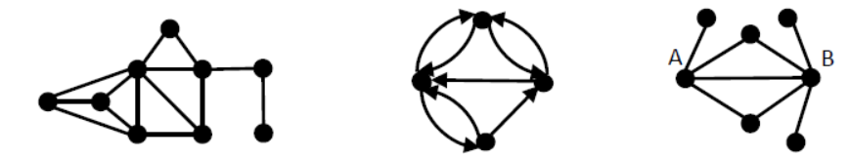

**a. Find a 3‐core in the first network.**

There is a 3-core showing below, each node of the subset is connected to at least 3 others:

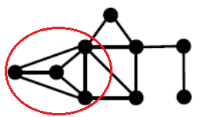

**b. What is the reciprocity of the second network?**

There are 8 directed edges in the graph. So, m = 8 while $r=\frac{1}{m}\sum_{ij}{{A_{ij}A}_{ji}=\frac{1}{m}TrA^{2}}$

There are 3 pairs of loop of length two in the network, which means $TrA^{2}=6$

So, we have $r=\frac{6}{8}=\frac{3}{4}$

**c. What is the cosine similarity of vertices A and B in the third network?**

$$σ_{ij}=cosθ=\frac{\sum_{k}{A_{ik}A_{kj}}}{\sqrt{\sum_{k}{A_{ik}^{2}}}\sqrt{\sum_{k}{A_{jk}^{2}}}}$$

Since this is an unweighted simple graph, we can change the expression to:

$$=\frac{n_{ij}}{\sqrt{k_{i}k_{j}}}=\frac{2}{\sqrt{4*5}}=\frac{\sqrt{5}}{5}$$

of which $n_{ij}$ is the number of common neighbors of A, B. And $k_{i} , k_{j}$ stand respectively for the degree of A and B. In conclusion, the cosine similarity is $\frac{\sqrt{5}}{5}$